POLITECNICO
DASTU
MILAN 26-28 JUNE 2017
Istituto La Casa
Via V. Lattuada, 14

Please fill the following reservation form and send it through e-mail to accoglienza@istitutolacasa.it in order to confirm your reservation within MAY, 30, 2017.
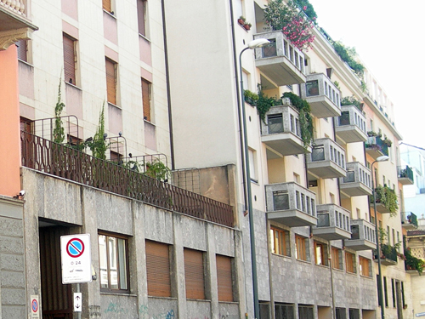
Istituto La Casa
Via V. Lattuada, 14 - 20135 Milano - Italy
Tel. (+39) 02 55 18 73 10
www.ist-lacasa.it
email. accoglienza@istitutolacasa.it

ROOMS RESERVATION

Please, write in the subject: Transforming Care Conference

Please confirm the following reservation:
Arrival date: _______________________________ (Check-in starting from …..)
Departure date: _______________________________ (Check-out until …….)

I would like to book:
a single room with private bathroom €45,00/night (housing only)

a single room with bathroom shared with another single room €50,00/night (housing only)

Please note that there is a limited number of rooms booked for each category, therefore those who book in advance will be privileged.

Name and address:__________________________________________________________________________
Address: ____________________________________________________________________________________
City/Town:__________________________________________________________________________________
Phone number:____________________________ Fax number: __________________________________
Credit card: _____________________________________________ Expiry date: _____________________
Signature: ___________________________________________________________________________________
Note well: the above-mentioned reservation is guaranteed. Cancellations over the deadline or no shows will involve a 100% charge of the entire reservation. In case you need to amend or cancel the reservation, we kindly ask you to do it within 8 days before your arrival.
____________________________________________________________________________________________
(date, stamp, signature)

