POLITECNICO
DASTU
MILAN 25-28 JUNE 2017
Hotel Gamma
Via V. Peroni, 85

Please fill the following reservation form and send it through e-mail to info@hotelgammamilano.it in order to confirm your reservation within MAY, 30, 2017.

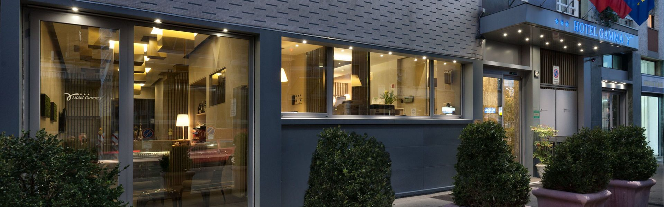
Hotel Gamma
Via V. Peroni, 85 - 20133 Milano - Italy
Tel. (+39) 02 26413152
www.hotelgammamilano.it
email. info@ hotelgammamilano.it

ROOMS RESERVATION
Please confirm the following reservation:
Arrival date: _______________________________ (Check-in starting from …..)
Departure date: _______________________________ (Check-out until …….)

N° ______ standard single room €.80,00/night (buffet breakfast included)
N° ______ double single use €. 100,00/night (buffet breakfast included)

Please note that there is a limited number of rooms booked for each category, therefore those who book in advance will be privileged.

Name and address:__________________________________________________________________________
Address: ____________________________________________________________________________________
City/Town:__________________________________________________________________________________
Phone number:____________________________ Fax number: __________________________________
Credit card: _____________________________________________ Expiry date: _____________________
Signature: ___________________________________________________________________________________
Note well: the above-mentioned reservation is guaranteed. Cancellations over the deadline or no shows will involve a 100% charge of the entire reservation. In case you need to amend or cancel the reservation, we kindly ask you to do it within 8 days before your arrival.
____________________________________________________________________________________________
(date, stamp, signature)

